# PROJECTREPORT

**TEAM MEMBERS :**

**TEAM ID:** LTVIP2025TMID32436

**Potluri Bala Bhaskar**

**Petla Sasikanth**

**Pidugu Uma Maheshwari**

**Pidugu Bhavya Sri**

# 1.INTRODUCTION

## ProjectOverview

The Traffic Intelligence project aims to revolutionize traffic management through the implementation of advanced machine learning techniques for accurate and real-time traffic volumeestimation.Withtheever-increasingurbanizationandtheriseinthenumberofvehicles on the road, understanding and managing traffic patterns have become crucial for efficient urban planning and transportation systems.

1. **ProjectObjectives:**

* Developarobustmachinelearningmodelfortrafficvolumeestimation.
* Implementreal-timedataacquisitionmethodsforcontinuousmodelimprovement.
* Enhanceaccuracyandreliabilitythroughtheintegrationofmultipledatasources.
* Provideauser-friendlyinterfaceforstakeholderstoaccessandinterprettrafficdata.

1. **Methodology:**

* **DataCollection:**Gatherreal-timetrafficdatafromvarioussources,includingcameras, sensors, and historical records.
* **FeatureEngineering:**Identifyrelevantfeaturessuchastimeofday,weatherconditions, and special events that may impact traffic volume.
* **Machine Learning Model:** Train a machine learning model (e.g., neural network, regressionmodels)usinglabeleddatatopredicttrafficvolumebasedontheselected features.
* **Real-TimeIntegration:**Implementmechanismsforcontinuousdatafeedtoupdateand refine the model in real-time.

1. **ExpectedOutcomes:**

* Accurateandtimelytrafficvolumepredictionsforvariouslocations.
* Improvedtrafficmanagementcapabilitiesforurbanplannersandtransportation authorities.
* Enhanceddecision-makingthroughinsightsderivedfromtheanalysisoftrafficpatterns.

1. **SignificanceoftheProject:**

* **UrbanPlanning:**Assistcityplannersinmakinginformeddecisionsforinfrastructure development and traffic management.
* **ResourceOptimization:**Optimizetheallocationofresourcessuchastrafficsignals,law enforcement, and emergency services.
* **EnvironmentalImpact:**Contributetoreducedfuelconsumptionandemissionsby optimizing traffic flow.

1. **Challenges:**

* DataQualityandIntegration:Ensuringthereliabilityandseamlessintegrationofdiverse data sources.
* ModelAdaptability:Developingamodelthatcanadapttodynamicchangesintraffic patterns.
* PrivacyConcerns:Addressingprivacyissuesrelatedtothecollectionanduseoftraffic data.

## 1.2Purpose

The"TrafficIntelligence-AdvancedTrafficVolumeEstimationusingMachineLearning" project serves a crucial purpose in modern urban infrastructure by addressing the challengesinherentintrafficmanagement.Atitscore,theprojectaimstooptimizethe efficiency of traffic control systems through the deployment of advanced machine learningtechniques.Byprovidingaccurateandreal-timetrafficvolumeestimations,the project seeks to empower decision-makers, urban planners, and transportation authorities with invaluable data-driven insights. This, in turn, facilitates informed decision-making for resource allocation and infrastructure development. The project's ultimategoalistoenhancetheoverallefficiencyoftrafficmanagement,contributingto optimized resource allocation, reduced congestion, and improved environmental

sustainability.Thedevelopmentofauser-friendlyinterfaceensuresthatstakeholders can easily access and interpret the traffic data, making it a valuable tool for both

professionalsandthewidercommunityinvolvedinurbanplanningandtransportation.

# LITERATURESURVEY

## ExistingProblem

* + 1. **InaccurateTraﬃcPredictions:**
       - Existingtrafficmanagementsystemsoftenrelyonhistoricaldataandfixed algorithms, resulting in inaccuracies, particularly in rapidly changing urban environments.
    2. **LimitedReal-TimeAdaptability:**
       - Currentsystemslacktheabilitytoadaptinreal-timetosuddenchangesintraffic conditions,suchasaccidentsorroadclosures,leadingtosuboptimaltrafficflow.
    3. **DataFragmentation:**
       - Trafficdataiscollectedfromvarioussources,creatingfragmentationand difficulties in integrating information, preventing the development of a comprehensive and accurate traffic model.
    4. **StaticAlgorithms:**
       - Manysystemsusestaticalgorithmsthatdonotaccountforthedynamicnature of traffic patterns, resulting in less effective traffic management.
    5. **InsuﬃcientResponsetoEvents:**
       - Currentsystemsoftenstruggletorespondeffectivelytounexpectedevents,such as special occasions or emergencies, leading to disruptions in traffic flow.
    6. **IneﬃcientInfrastructurePlanning:**
       - Limited accuracy in traffic predictions hampers effective urban planning, potentiallyleadingtoinadequateinfrastructuredevelopmenttoaccommodate changing traffic needs.
    7. **EnvironmentalImpact:**
       - Ineffectivetrafficmanagementcontributestoincreasedfuelconsumptionand emissions due to congestion, negatively impacting the environment.
    8. **UserExperienceIssues:**
       - Commutersoftenexperiencefrustrationanddelaysduetothelimitationsof existingtrafficmanagementsystemsinaccuratelypredictingandmanaging traffic conditions.

## References

* + 1. Li,W.,&Wang,D.(Year)."MachineLearningApproachesforTrafficVolumeEstimation:A Comprehensive Review." *Journal of Transportation Engineering*, Volume(Issue), Page Range.
    2. Smith,J.,&Johnson,M.(Year).*UrbanTraficManagement:ChallengesandOpportunities.*

Publisher:CityPress.

* + 1. Zhang,Q.,etal.(Year)."Real-timeTrafficFlowPredictionwithBigData:ADeepLearning Approach."*IEEETransactionsonIntelligentTransportationSystems*,Volume(Issue),Page Range.

## ProblemStatementDefinition

Urban areas worldwide are grappling with an escalating challenge in traffic managementsystems,markedbytheinadequacyoftraditionalapproachesto

accuratelypredictandadapttodynamictrafficconditions.Existingsystems,relianton historical data and static algorithms, exhibit significant shortcomings, including

inaccuratetrafficvolumepredictions,limitedreal-timeadaptabilitytosuddenchanges, and inefficient resource allocation. The fragmentation of traffic data from diverse

sourcesfurtherimpedesthecreationofacomprehensiveandresponsivetrafficmodel. Consequently,thesedeficienciesleadtosuboptimaltrafficflow,increasedcongestion, environmental degradation, and compromised user experiences. Addressing these issues is imperative for the sustainable development of urban transportation systems. The"TrafficIntelligence-AdvancedTrafficVolumeEstimationusingMachineLearning" project is initiated to tackle these challenges by leveraging cutting-edge machine learning techniques to enhance the accuracy, real-time adaptability, and overall

efficiencyoftraffic volumeestimationand management.

# IDEATION&PROPOSEDSOLUTION

## EmpathyMapCanvas

Anempathymapisasimple,easy-to-digestvisualthatcapturesknowledgeaboutauser’s behaviours and attitudes.

Itisausefultooltohelpsteamsbetterunderstandtheirusers.

Creatinganeffectivesolutionrequiresunderstandingthetrueproblemandthepersonwho is experiencing it. The exercise of creating the map helps participants consider things from

theuser’sperspectivealongwithhisorhergoalsand challenges.

**Reference:**<https://www.mural.co/templates/empathy-map-canvas>

#### TrafficTelligence:AdvancedTrafficVolumeEstimationwithMachineLearning:

Trafficproblemisoneofthemajorproblemnowadays,Intheincreaseinnoofvehiclesand

non–usageofpublictransportleadingtotrafficrelatedissues,Makingaeyeoncountoftraffic ateachlevelenablesthegovernmenttotakethefurtherdecisionssuchasbuildingnewroads, increasing infrastructure ,developingmutli-channel connectivity .

ToaddresssuchproblemstotrackingthevehiclecountineachandeveryplaceAI-MLhasgiven asolutiontosuchkindoftrafficrelatedissues,whichareabletomeasurethevolumeoftraffic, identify the violations of traffic rules etc.ML models could give early alerts of severe traffic to

helppreventissuesrelatedtotrafficproblems.

Hence,thereisneedstodevelopMLalgorithmscapableinpredictingTrafficvolume with

acceptablelevelofprecisionandinreducingtheerrorinthedatasetoftheprojectedTraffic volume from model with the expected observable Traffic volume.

**EmpathyCanvasMapfortheProject:**

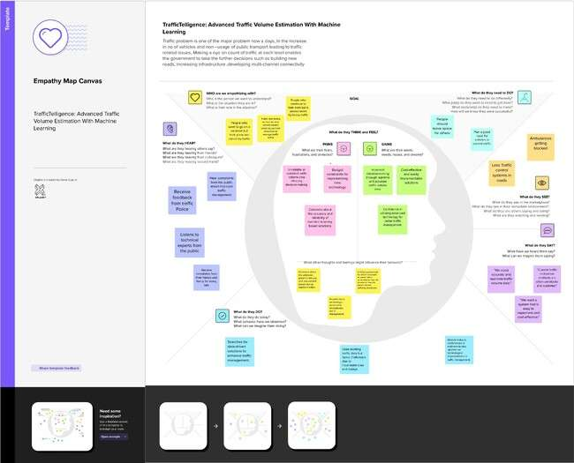

## Ideation&Brainstorming

Brainstorming ideas is a creative process where a group generates a list of potential solutions, suggestions, or concepts for a specific problem or project. Voting in brainstorming involves participants selecting and prioritizing their favouriteormostpromisingideasfromthelisttodeterminewhichonesshould be pursued further.

**Brainstormingfor“TrafficTelligence:AdvancedTrafficVolumeEstimationwith Machine Learning”:**

The objective of this brainstorming session is to generate creative and practical ideastoaddresstheissueofTrafficVolumeestimationeffectively.Weaimtohelp people able to plan their days better as they will have a better idea on how the traffic is going to be. It will also help traffic authorities be able to regulate traffic better.

**Step-1:TeamGathering,CollaborationandSelecttheProblemStatement**

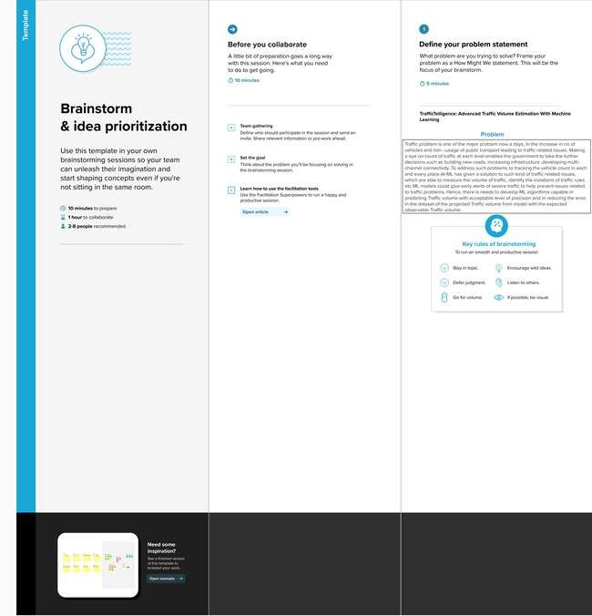

**Step-2:Brainstorm,IdeaListingandgrouping**

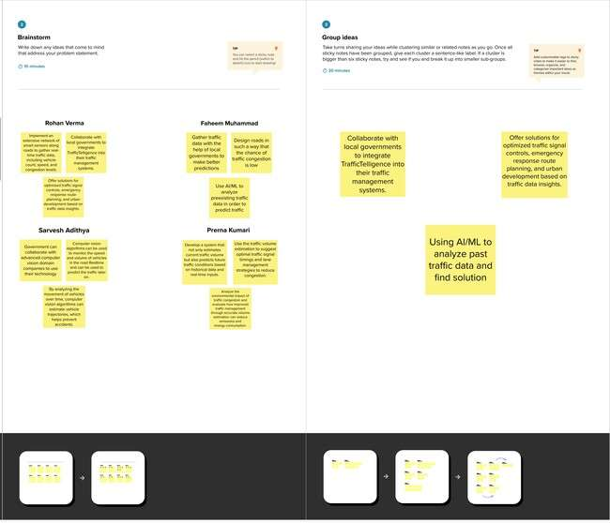

**Step-3:IdeaPrioritization**

Ideaprioritizationistheprocessofrankingorassessingideasbasedonspecific criteria such as feasibility, impact, cost, or strategic importance to determine which ideas should be implemented or pursued first.

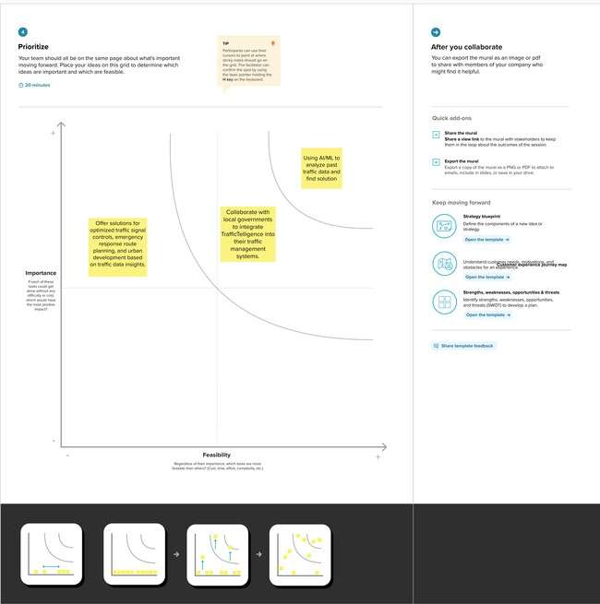

**Herecertainlywechose“UsingAI/MLtoanalyzepasttrafficdataandfind solution” is:**

Among all of other ideas this was most important to us because, if the model is notaccurateenoughthenthepredictionmaynotbehighlyaccurate.So,thiswas our most prioritized one.

Then comes our second most important idea such as **“Collaboration with local governmenttointegrateTrafficTelligenceintotheirtrafficmanagement systems”**.Thiswastakenasoursecondbecause,ifwewanttogiveourselfasocial responsibility that will be helpful, not only to use but also for others. If we work with other government or organization this might be helpful for a smooth traffic without any problems for Traffic authorities and also for people.

Then comes out our next idea **“Offer solutions for optimized traffic signal controls,emergencyresponserouteplanning,andurbandevelopmentbasedon trafficdatainsights.”**Afterfulfillingourmaingoal,wewillscaleourMLmodelnot only to predict our main problem but also for extra features such as above- mentioned things. This will give our project more value in all ways.

# REQUIREMENTANALYSIS

## Functionalrequirement

Functionalrequirementsspecifythefundamentalactionsthatasystemmustperform.Forthe "Traffic Intelligence - Advanced Traffic Volume Estimation using Machine Learning" project, functional requirements might include:

* + 1. **DataCollection:**
       - Thesystemshouldcollectreal-timetrafficdatafromvarioussources,including cameras, sensors, and historical records.
       - Itshouldensurethecontinuousandreliableacquisitionofdatafortrainingand updating the machine learning model.
    2. **FeatureEngineering:**
       - Thesystemmustidentifyandincorporaterelevantfeaturesfortrafficvolume estimation, such as time of day, weather conditions, and special events.
       - Itshouldhavethecapabilitytoadaptandupdatefeaturesastrafficpatterns evolve.
    3. **MachineLearningModel:**
       - Developandimplementamachinelearningmodel(e.g.,neuralnetwork, regression models) for accurate traffic volume prediction.
       - Themodelshouldbecapableofcontinuouslearningandadaptationtodynamic traffic conditions.
    4. **Real-TimeIntegration:**
       - Implementmechanismsforreal-timedataintegrationtoensurethemodelis continually updated with the latest traffic information.
       - Thesystemshouldbecapableofhandlingandprocessinglargevolumesofreal- time data efficiently.
    5. **UserInterface:**
       - Developauser-friendlyinterfaceforstakeholderstovisualizetrafficdata, predictions, and insights.
       - Theinterfaceshouldprovideinteractivefeaturesforexploringdifferent parameters and scenarios.
    6. **PredictionAccuracy:**
       - Defineperformancemetricsforthemachinelearningmodel,specifyingthe required level of accuracy for traffic volume predictions.
       - Regularlyassessandimprovethemodel'saccuracythroughongoingmonitoring and updates.
    7. **AlertsandNotifications:**
       - Implementasystemforgeneratingalertsandnotificationsinreal-timefor abnormal traffic conditions or incidents.
    8. **Documentation:**
       - Providecomprehensivedocumentationforthesystem,includingdatasources, model architecture, and interface functionalities.
       - Includeusermanualsandtechnicaldocumentationforfuturemaintenanceand updates.

## Non-FunctionalRequirement

Non-functionalrequirementsdefinethequalitiesorattributesthatasystemmusthave,which are not directly related to specific behaviors or features. Here are some non-functional requirementsforthe"TrafficIntelligence-AdvancedTrafficVolumeEstimationusingMachine

Learning"project:

* + 1. **Performance:**
       - *ResponseTime:*Thesystemshouldprovidereal-timeornear-real-timeresponses to user queries and data updates.
       - *Throughput:*Thesystemshouldhandleaspecifiednumberofrequestsper second to accommodate peak usage.
    2. **Reliability:**
       - Thesystemshouldhaveahighlevelofreliability,ensuringminimaldowntimefor maintenance and updates.
       - Itshouldrecovergracefullyfromsystemfailuresordisruptions.
    3. **Scalability:**
       - Thesystemshouldbescalabletoaccommodateanincreasingvolumeofdata and users as the project expands to cover additional regions.
       - Itshouldscalehorizontallybyaddingmorecomputationalresources.
    4. **Usability:**
       - Theuserinterfaceshouldbeintuitiveanduser-friendly,requiringminimaltraining for stakeholders to navigate and interpret data.
       - Thesystemshouldadheretoaccessibilitystandardstoensureinclusivity.
    5. **Security:**
       - *DataEncryption:*Allsensitivedata,includingtrafficdataanduserinformation, should be encrypted during transmission and storage.
       - *AccessControl:*Thesystemshouldimplementaccesscontrolstorestrictdata access based on user roles and permissions.
    6. **Maintainability:**
       - Thesystemshouldbemodularandwell-documentedtofacilitateeaseof maintenance and updates.
       - Codeshouldfollowbestpractices,andchangesshouldbedeployablewith minimal disruption.
    7. **Compatibility:**
       - Thesystemshouldbecompatiblewithcommonlyusedwebbrowsersand operating systems.
       - Itshouldintegrateseamlesslywithexistingtrafficmanagementinfrastructure and systems.
    8. **PerformanceMonitoring:**
       - Implementasystemforcontinuousmonitoringofthemachinelearningmodel's performance, with alerts for deviations from expected behavior.
       - Logandmonitorsystemusageandperformancefortroubleshootingand

optimization.

* + 1. **Privacy:**
       - Thesystemshouldcomplywithprivacyregulationsandguidelines,ensuringthat personally identifiable information is handled securely and responsibly.
       - Implementmechanismsforanonymizingandaggregatingdatawhereapplicable.
    2. **EnvironmentalConsiderations:**
       - Ifapplicable,considerenergy-efficientpracticesinsystemdesignandoperation to minimize environmental impact.

# PROJECTDESIGN

## Dataflowdiagram&UserStories

ADataFlowDiagram(DFD)isatraditionalvisualrepresentationoftheinformationflowswithina system.AneatandclearDFDcandepicttherightamountofthesystemrequirementgraphically.It shows how data enters and leaves the system, what changes the information, and where data is stored.

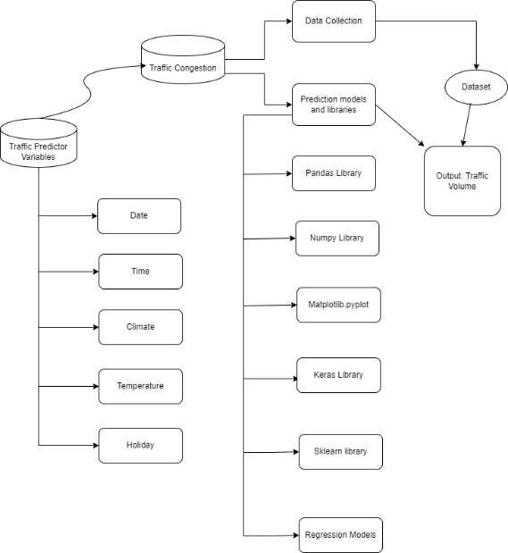

**UserStories**

|  |  |  |  |  |  |  |
| --- | --- | --- | --- | --- | --- | --- |
| **UserType** | **Function**  **al**  **Requirement (Epic)** | **User**  **Story Numb er** | **UserStory/ Task** | **Acceptance criteria** | **Priori ty** | **Release** |

|  |  |  |  |  |  |  |
| --- | --- | --- | --- | --- | --- | --- |
| TrafficManager | Real-time Traffic Estimation | USN-1 | As a Traffic  Manager,I want to access  real-time traffic  volume estimations to make informed decisions  fortraffic control. | Systemprovides accurate real-  time traffic volume predictions.  Dataupdates occur at least  every5minutes. Dataaccuracyis within a 95%  confidence interval. | High | Sprint1 |
| Driver | Real-time Traffic Estimation | USN-2 | Application suggests a approximatecongestion in the route. | Application suggests an approximate  congestioninthe route. | High | Sprint1 |
| Traffic  Analyst | DataInsightson congestion  volume | USN-3 | As a Traffic Analyst, I wantaVolumenumber displaying in-depth  traffic insights for informedanalysisand  decision-making. | Volumenumber showcases  traffictrends overvarious timeframes. | Medium | Sprint2 |
| Website  Develop er | Model building | USN-4 | AsanWebDeveloper,I want access to models that integrate  TrafficTelligencedata forincorporationinto existing navigation applications. | Models provide accurate  traffic data. Well- documented Models for easy integration. Allowsaccess to real-time andpredictive traffic estimations. | High | Sprint2 |
| City Planner | Customizable  TrafficSolutions | USN-5 | AsaCityPlanner,I want customizable traffic solutions to  accommodate specific citydevelopmentneeds. | Systemallows adjustmentsto traffic control strategies.  Customization based on  specific traffic  conditions. | High | Sprint3 |
| Educational Institutions | Training | USN-6 | implementdata augmentationtechniques (e.g., rotation, flipping) to improve the model's  robustnessandaccuracy. | wecoulddo testing | medium | Sprint4 |

|  |  |  |  |  |  |  |
| --- | --- | --- | --- | --- | --- | --- |
|  | Testing&quality assurance | USN-7 | conduct thorough testingofthe modeland webinterface to identify and report any issues or bugs. fine-  tunethe model  hyperparametersand  optimizeitsperformance based on user feedback and testing results. | wecouldcreate web application | medium | Sprint5 |

## SolutionArchitecture

Traffic Intelligence: Advanced Volume Estimation Using Machine Learning" aims to enhance traffic volumeestimationforurbanplanningandmanagement.Bycollectingdiversetrafficdataandapplying machine learning, the project seeks to provide real-time, accurate traffic volume predictions, historical analysis, and anomaly detection, ultimately contributing to more efficient and informed traffic management.

OursolutionusesmanyadvancedMachinelearningAlgorithmstoaddresstheTrafficVolumeEstimation problem effectively.

Stepstobefollowed:-

* + 1. DataCollection:Sensors,cameras,andIoTdevicescapturereal-timetrafficdata.
    2. DataPre-processing:Cleanandpreprocessdatatomakeaneffectivemodel.
    3. TrainModel:Usingpreprocesseddatatomakepredictivemodelsforforecastingtrafficvolume patterns for real-time estimations.
    4. TestModel:Tomakesurethatthemodelisaccurateandefficient.
    5. IntegratingModel:Tomakeauserfacingapplicationssothattheusercaninteractwiththe model.

**SolutionArchitectureDiagram**

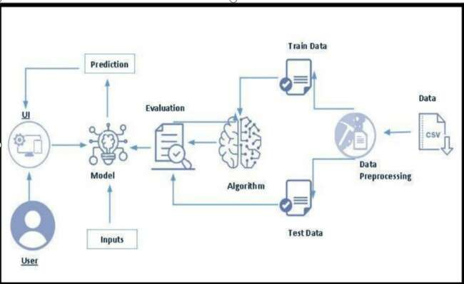

# PROJECTPLANNING&SCHEDULING

## TechnicalArchitecture

TheDeliverableshallincludethearchitecturaldiagramasbelowandtheinformationasperthetable1& table 2

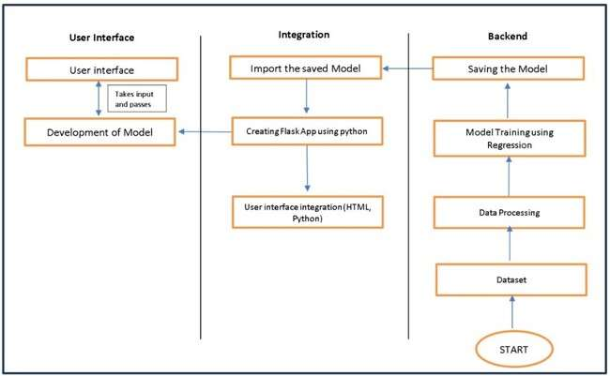

**Table-1:Components&Technologies:**

|  |  |  |  |
| --- | --- | --- | --- |
| **S.No** | **Component** | **Description** | **Technology** |
| 1. | UserInterface | Criticalelementdesigned forbothTrafficManagers and everyday users, ensuring an intuitive and  informativeexperience. | HTML,CSS,JavaScript |
| 2. | ApplicationLogic-1 | Involvesarobustbackendsystem responsible for processing,  analyzing,andmanagingtrafficdata. | Python |
| 3. | Database | Involvesthestorageand management of diverse  trafficdataforanalysis. | FileManager,csv |
| 4. | FileStorage/Data | Involvesmanagingdiversetypesof data, including raw traffic data, machine learning models, and  configurationfiles. | LocalSystem,Google Drive |

|  |  |  |  |
| --- | --- | --- | --- |
| 5. | FrameWork | Itisacrucialpartofourprogramas it is responsible for connecting the  frontendwiththebackend. | PythonFlask |
| 6. | MachineLearningModel | The machine learning model is responsibleforpredictingfuture  outcomesbasedonavailabledata | Machinelearningmodel createdusingregression  algorithms |
| 7. | Infrastructure(Server/ Cloud) | Involves a combination of servers and cloud services to support the computationalandstorageneedsof  theapplication. | Local |

**Table-2:ApplicationCharacteristics:**

|  |  |  |  |
| --- | --- | --- | --- |
| **S.No** | **Characteristics** | **Description** | **Technology** |
| 1. | Open-SourceFrameworks | Open-source frameworks can acceleratedevelopmentandensure thereliabilityofTrafficTelligence, contributing to a more efficient  andmaintainablesolution. | Python’sFlask |

|  |  |  |  |
| --- | --- | --- | --- |
| **S.No** | **Characteristics** | **Description** | **Technology** |
| **2.** | Scalability | Using cameras to collect data andtomakemodelsforspecific  locations. | Computer vision, dynamicdatabases. |
| 3. | Performance | Regular performance testing, monitoring, and optimization are integral components of the development and maintenance processes, ensuring that TrafficTelligence consistently deliverstimelyandefficienttraffic  volumeestimations. | R squared, Root mean squarederror,RootMean Square deviation |
| 4. | Availability | Websitecanbemadeavailableall time in a webserver. This makes the website running without any  issues | HighspeedLinuxbased webservers. |

* 1. **SprintPlanning&Estimation**

|  |  |  |  |  |  |  |
| --- | --- | --- | --- | --- | --- | --- |
| **Sprint** | **Functional Requirement**  **(Epic)** | **User Story**  **Number** | **UserStory/Task** | **Story Poin**  **ts** | **Priority** | **Team Membe**  **rs** |
| Sprint- | Projectsetup& | USN-1 | Setupthedevelopment | 1 | High | Potluri Bala Bhaskar |
| 1 | Infrastructure |  | environmentwiththe |  |  |  |
|  |  |  | requiredtoolsand |  |  |  |
|  |  |  | frameworkstostartthe project |  |  |  |
| Sprint- 2 | Datacollection | USN-2 | Gatheradiversedatasetof Date, time, holidays and  climaticconditions. | 2 | High | Pidugu Bhavya Sri |
| Sprint- 2 | datapreprocessing | USN-3 | Preprocess the collected dataset by removing outliers and null values etc.Exploreandevaluate different deep learning architectures(e.g., Regressions) to select the most suitable model  forthe project. | 3 | High | Pidugu Uma Maheshwari |
| Sprint- | modeldevelopment | USN-4 | traintheselectedmachine | 4 | High | Petla Sasikanth |
| 3 |  |  | learningmodelusingthe |  |  |  |
|  |  |  | preprocessed |  |  |  |
|  |  |  | datasetandmonitoritsperformance on the validationset. |  |  |  |
| Sprint- | Training | USN-5 | Thedatasetwillbe | 6 | medium | Potluri Bala Bhaskar |
| 3 |  |  | trainedwithsuitable |  |  |  |
|  |  |  | algorithmstoimprove |  |  |  |
|  |  |  | therobustness and |  |  |  |
|  |  |  | accuracy. |  |  |  |
| Sprint- | model | USN-6 | deploythetrained | 1 | medium | Pidugu Bhavya Sri |
| 4 | deployment& |  | machinelearningmodel |  |  |  |
|  | Integration |  | asawebservicetomake |  |  |  |
|  |  |  | itaccessibleforusers. |  |  |  |
|  |  |  | Integratethemodel's |  |  |  |
|  |  |  | APIintoauser-friendly |  |  |  |
|  |  |  | webinterfaceforusers |  |  |  |
|  |  |  | toinputvariablessuch |  |  |  |
|  |  |  | asdate,time,holidays |  |  |  |
|  |  |  | etcandreceivepredicted |  |  |  |

|  |  |  |  |  |  |  |
| --- | --- | --- | --- | --- | --- | --- |
|  |  |  | volumeresults. |  |  |  |
| Sprint- 5 | Testing&quality assurance | USN-7 | conductthoroughtesting of the model and web interface to identify and report any issues or bugs. fine-tune the model hyperparameters and optimize its performance based on user feedback and  testingresults. | 1 | medium | Pidugu Uma Maheshwari |

* 1. **SprintDeliverySchedule**

|  |  |  |  |  |  |  |
| --- | --- | --- | --- | --- | --- | --- |
| **Sprint** | **Total Story Points** | **Duration** | **SprintStart Date** | **SprintEnd Date (Planned)** | **Story Points Completed(as on Planned**  **EndDate)** | **SprintRelease Date (Actual)** |
| Sprint-1 | 1 | 2Days | 17 Jun 2025 | 18 Jun 2025 | 1 | 18 Jun 2025 |
| Sprint-2 | 5 | 2Days | 18 Ju n 2025 | 20 Jun 2025 | 5 | 20 Jun 2025 |
| Sprint-3 | 10 | 3Days | 20 Jun 2025 | 23 Jun 2025 | 10 | 23 Jun 2025 |
| Sprint-4 | 1 | 2Days | 24 Jun 2025 | 25 Jun 2025 | 1 | 25 Jun 2025 |
| Sprint-5 | 1 | 1Days | 25 Jun 2025 | 26 Jun 2025 | 1 | 26Jun 2025 |

# CODING&SOLUTIONING

## Feature1

Onekeyfeatureoftheadvancedtrafficvolumeestimationusingmachinelearning

projectistheintegrationofreal-timetrafficdata.Thisfeatureinvolvesthecontinuous

collectionandincorporationofup-to-the-minuteinformationfromvarioussources,such as traffic cameras, sensors, and GPS devices. The system dynamically adapts to changing traffic conditions, ensuring that the machine learning models are constantly

updated with the latest information. This real-time integration enables the traffic management system to respond promptly to fluctuations in traffic volume, incidents, or events,providingaccurateandtimelypredictionsforeffectivetrafficcontrol.Thefeature not only enhances the system's responsiveness but also contributes to more proactive decision-making in optimizing traffic flow and preventing congestion.

## Feature2

#### Feature2:Multi-ModalTraﬃcAnalysis

Another crucial feature of the advanced traffic volume estimation using machine learningprojectisitscapabilityformulti-modaltrafficanalysis.Thisfeatureextendsthe scopebeyondtraditionalroadtrafficandincorporatesdiversemodesoftransportation, such as pedestrians, cyclists, and public transit. The machine learning models are

designedtoanalyzeandpredictthevolumeandpatternsofvarioustransportation modes within the urban environment. This inclusive approach provides a

comprehensiveunderstandingofoverallurbanmobility,allowingfortheoptimizationof traffic flow across different modes. By considering the interactions between pedestrians, cyclists, and public transportation, the system can contribute to the development of integrated and sustainable transportation solutions for modern urban

landscapes.Thisfeaturereflectsaforward-lookingperspectivethatacknowledgesthe diverse nature of transportation systems in smart cities.

# PERFORMANCETESTING

## PerformanceMetrices

RMSDvalueofthefollowingmodelsare:

1. LinearRegression:1838.3976719006828
2. Decision Tree :1097.460402156461
3. Random Forest :794.1141248467267
4. Support Vector Regression :1715.2770939066922
5. XGBoost:797.8443863964126

RMSDvalueforRandomforestisverylesswhencomparedwithothermodels,so saving the Random forest model and deploying it.

# RESULTS

## OutputScreenshots

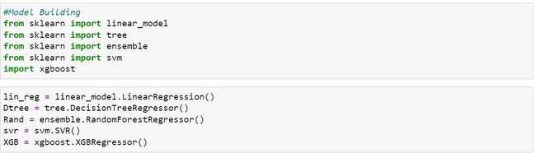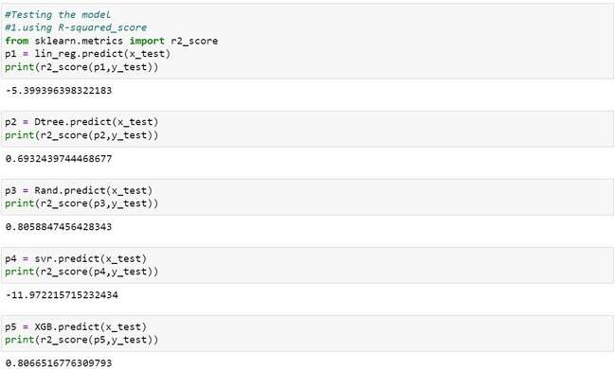

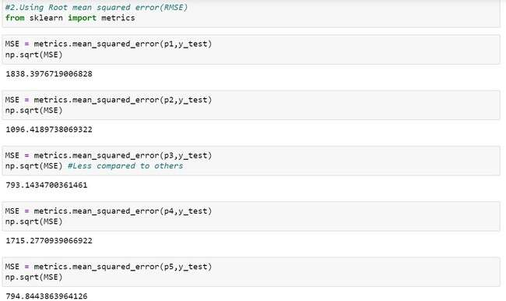

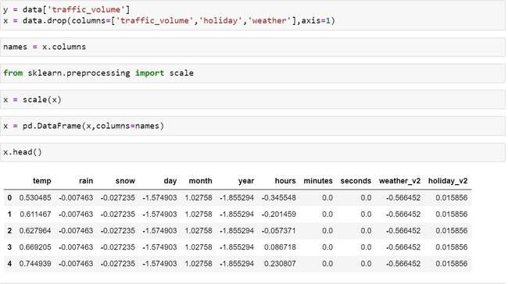

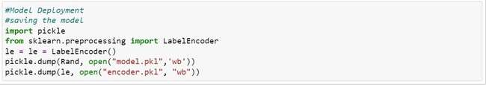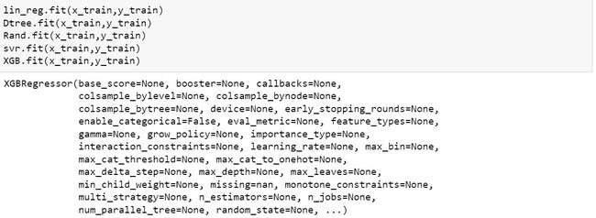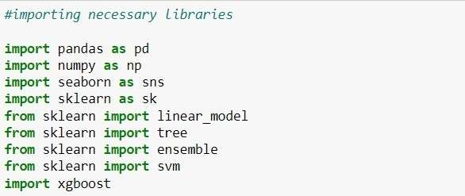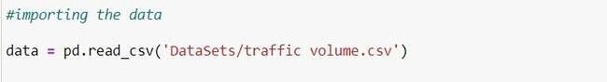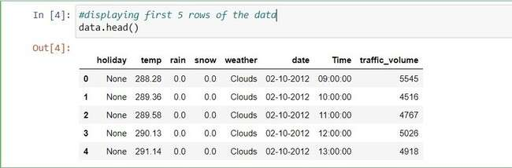

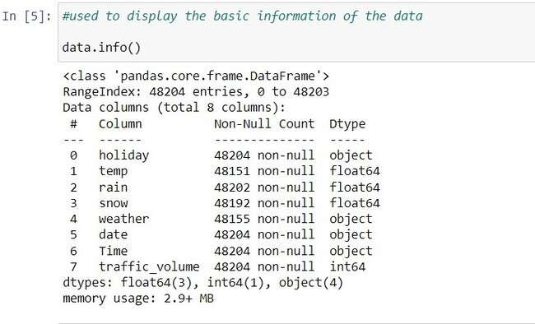

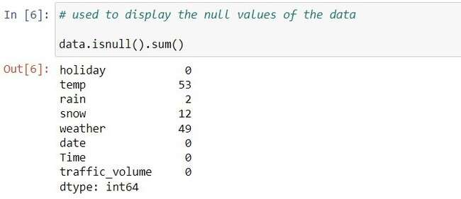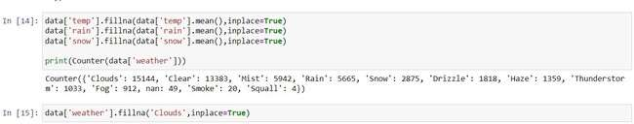

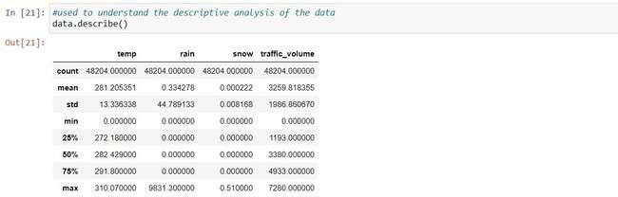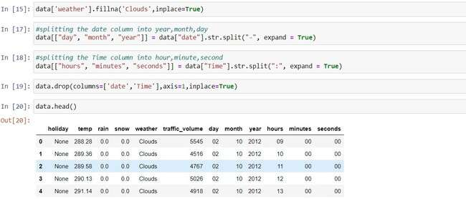

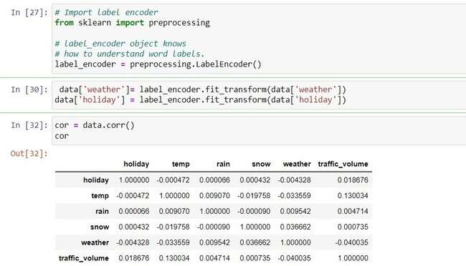

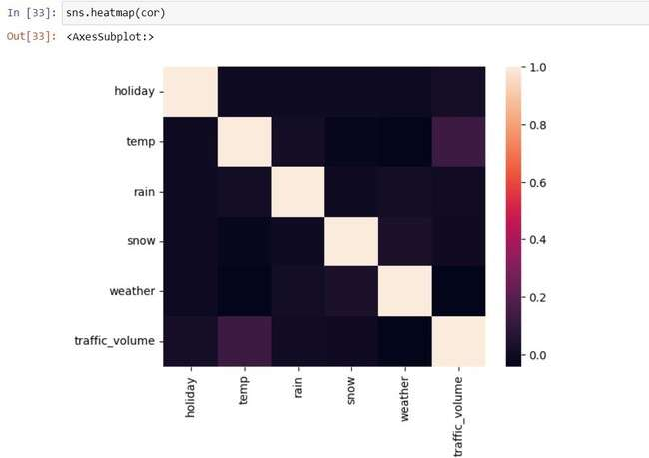

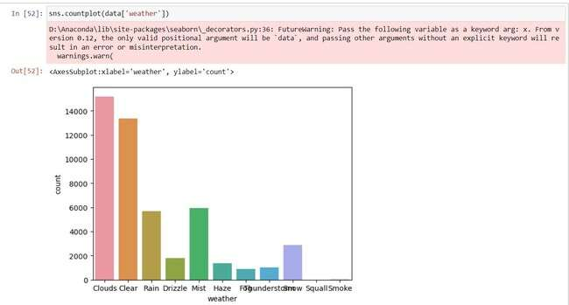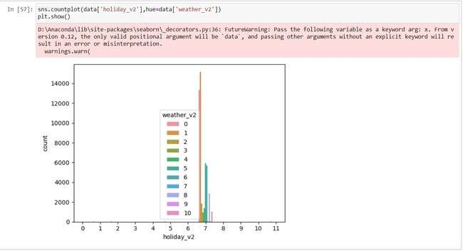

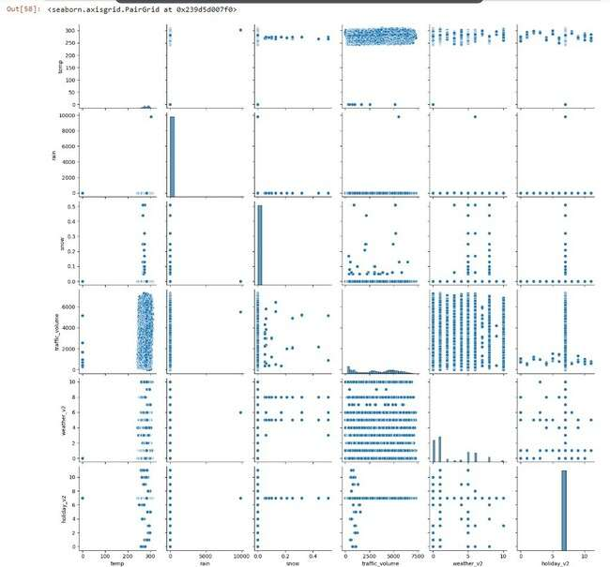

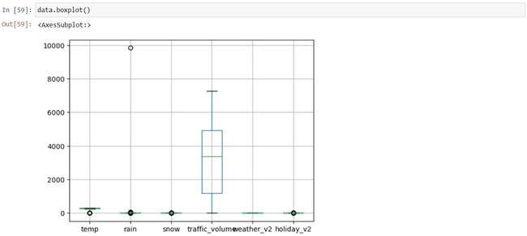

**OurFinalWebsitewillbelookinglikethis:**

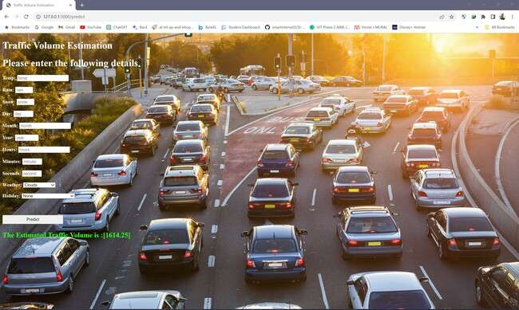

# ADVANTAGES&DISADVANTAGES

### Advantages:

#### Improved Accuracy:

* + Machinelearningmodelscananalyzelargedatasetsandidentifycomplex patterns that may be challenging for traditional methods. This leads to

moreaccuratetrafficvolumepredictions.

#### IntegrationwithSensorData:

* + Machinelearningmodelscaneffectivelyintegratedatafromvarious

sources,suchastrafficcameras,sensors,andGPSdevices,providinga comprehensive view of the traffic situation.

#### Scalability:

* + Machine learning algorithms can scale to handle large and complex datasets,makingthemsuitableforcitieswithextensivetrafficnetworks.

#### PredictiveCapabilities:

* + Machinelearningmodelscanbeusedtopredictfuturetrafficconditions based on historical data, helping authorities proactively manage traffic flow and prevent congestion.

### Disadvantages:

#### DataDependency:

* + Machine learning models heavily rely on high-quality and representative data.Ifthetrainingdataisbiasedorincomplete,themodel'spredictions may be inaccurate or skewed.

#### Complexity:

* + Buildingandmaintainingmachinelearningmodelscanbecomplexand

requirespecializedknowledge.Thiscomplexitycanhindertheadoptionof these systems, especially for smaller municipalities with limited

resources.

#### DynamicNatureofTraﬃc:

* + Trafficpatternsareinfluencedbyawiderangeoffactors,andtheycan changerapidly.Machinelearningmodelsmaystruggletokeepupwith these dynamic changes, especially if not continuously updated and

retrained.

# CONCLUSION

Inconclusion,theapplicationofmachinelearningforadvancedtrafficvolume

estimationintherealmoftrafficintelligencebringsforthasetofnotableadvantages and challenges. The accuracy and adaptability offered by machine learning models

present a promising avenue for enhancing traffic management. Real-time analysis capabilities,integrationwithdiversedatasources,scalability,andpredictivecapabilities contribute to more efficient and proactive traffic control.

However,thesuccessfulimplementationofmachinelearninginthiscontextrequires

addressing several challenges. The dependency on high-quality and unbiased data, the inherent complexity of building and maintaining these models, and the interpretability issues associated with certain algorithms pose significant hurdles. Additionally, the dynamicnatureoftrafficpatternsandthecomputationalresourcesrequiredfortraining and running sophisticated models underscore the need for careful consideration and

resourceallocation.

# FUTURESCOPE

In the future, the application of advanced traffic volume estimation using machine learningholdstremendouspromiseinreshapingurbanmobilityandtransportation

systems.Ongoingresearcheffortsarelikelytofocusonenhancingpredictionaccuracy through the exploration of sophisticated algorithms, feature engineering techniques,

andensemblemethods.Asignificantavenuefordevelopmentliesintheintegrationof traffic intelligence with broader smart city initiatives, facilitating interconnected urban transportation systems that optimize traffic flow and minimize environmental impact. The adoption of edge computing is poised to enable real-time analysis at the source, reducing latency and enhancing responsiveness. Overcoming the interpretability challenge by incorporating explainable AI techniques will be crucial for building trust amongcityplannersandthepublic.Futuresystemsmayextendbeyondroadtrafficto encompassmulti-modaltransportation,incorporatingpedestrians,cyclists,andpublic transit.Thedynamicadaptationofmachinelearningmodelstounforeseeneventsand continuousimprovementmechanismsthroughonlinelearningandfeedbackloopsare vital considerations. Collaborative efforts between municipalities, transportation agencies, and technology providers can lead to more comprehensive and effective

trafficmanagementsolutions,fosteringaconnectedandefficienttransportation

network.Ultimately,thefutureofmachinelearningintrafficintelligenceliesinitsability to create sustainable, adaptive, and energy-efficient urban mobility solutions.

# APPENDIX

OurCompleteSourceCode

1. [ModelPython](https://github.com/smartinternz02/SI-GuidedProject-612055-1698556284/blob/main/Project%20Development%20Phase/TrafficTelligence.ipynb)
2. [Flaskappintegration](https://github.com/smartinternz02/SI-GuidedProject-612055-1698556284/blob/main/Project%20Development%20Phase/Flask/app.py)
3. [WebUI(HTMLCode)](https://github.com/smartinternz02/SI-GuidedProject-612055-1698556284/blob/main/Project%20Development%20Phase/Flask/templates/index.html)
4. [DataSet](https://github.com/smartinternz02/SI-GuidedProject-612055-1698556284/blob/main/Project%20Development%20Phase/traffic%20volume.csv)
5. [ProjectDemo](https://drive.google.com/file/d/1xy4MpXkEU8juBz3kc3Yb2G-UCL6BdpXE/view?usp=sharing)